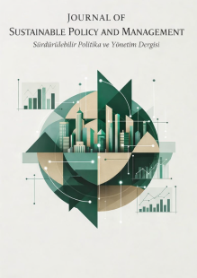 | Journal of Sustainable Policy and Management  Sürdürülebilir Politika ve Yönetim Dergisi

DECLARATION FORM STATING THAT ETHICS COMMITTEE APPROVAL IS NOT REQUIRED

Title of the Manuscript
Date

We hereby declare that the study whose details are provided above falls within the scope of studies that do not require ethics committee approval.
(Ethics Committee Approval is required for all types of research conducted using qualitative or quantitative approaches that involve collecting data from participants through surveys, interviews, focus group discussions, observations, experiments, or interview techniques; for the experimental or other scientific use of humans and animals (including materials/data); for clinical research conducted on humans; for research conducted on animals; and for retrospective studies subject to personal data protection regulations.)

 | Author(s) | Signature | Date
1 | …………………………………………. | ………………………… | ………………………
2 | …………………………………………. | ………………………… | ………………………
3 | …………………………………………. | ………………………… | ………………………
4 | …………………………………………. | ………………………… | ………………………
5 | …………………………………………. | ………………………… | ………………………
6 | …………………………………………. | ………………………… | ………………………

