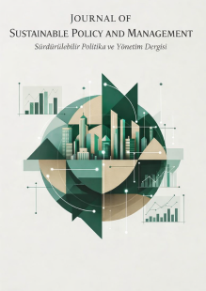 | Journal of Sustainable Policy and Management  Sürdürülebilir Politika ve Yönetim Dergisi

COPYRIGHT TRANSFER FORM

Title of the Manuscript: .........................................................
Name and Address of the Corresponding Author: .........................................................
National ID Number: .........................................................
E-mail: .........................................................
Telephone / Mobile Phone: .........................................................
Author(s):
The authors hereby declare that the submitted manuscript is their original work and that no plagiarism has been committed; that all authors have individually contributed to this study and have assumed full responsibility for the content of the work; that all authors have seen and approved the final version of the submitted manuscript; that the manuscript has not been published elsewhere and is not under consideration for publication elsewhere; and that the text, figures, and documents included in the manuscript do not infringe upon the copyrights of third parties.
As the corresponding author, I hereby declare that the editors of the Journal of Sustainable Policy and Management bear no responsibility for any claims or lawsuits that may be brought by third parties due to copyright infringement, and that all responsibility rests with me. I also declare that the manuscript contains no criminal or unlawful content and has been conducted in accordance with ethical principles.

Full Name of the Corresponding Author : ........................................
Signature : ........................................

Order | National ID Number | Adı Soyadı | Date | Signature
(The Copyright Transfer Form must be signed by all authors. All signatures must be handwritten.)

